Patient’s Guide to
The Waiting Room
Version 1.1
Date: 5-Jul-16
Contents
Registering for The Waiting Room with your practice 3
Account Details 4
Creating an account at TWR 4
First visit to The Waiting Room 4
Subsequent visits to The Waiting Room 6
Lost or forgotten Username/Password 6
The Waiting Room - Home page showing the appointments and prescriptions 7
Appointments 8
The Booking Screen 8
Successful booking 9
Cancellation 9
Appointment Cancel screen 9
Appointment Diary 10
Prescriptions 11
Information on display 11
My Prescriptions 11
Ordering a prescription 12
Drug order screen 12
Acknowledgement - showing the order 13
Prescription Raised 13
Early Re-order warning 13
My Care Record 13
Heading 13
SCR consent 13
Allergies and Adverse reactions 13
My Care Record - Heading, Allergies and Adverse drug reactions 14
Acute Medication 14
Current Repeat medication and Discontinued Repeat Medication 15
Proxy Access 16
Appendix A - Summary Care Record - Core Data Items 17
Allergies and Adverse Reactions 17
Current Repeat Medications 17
Acute Medication 17
Discontinued Repeat Medications 17

Registering for The Waiting Room with your practice
In order to access the online facilities offered by your practice you will need to create an account on The Waiting Room website – www.thewaitingroom.net.
Note: the username you select to use is required to be unique and chosen by you as the Online User.

To begin the process of registering to become and Online Service User you will need to give your email address to your practice.
Note: due to patient confidentiality joint email accounts cannot be supported e.g. AlanandJoanSmith@btinternet.com
The practice will record your email address within their clinical system and it will send an automated email to you in order to verify the email address – this needs to be confirmed within 48 hours.
You need to click on the link within the email which will then take you to a page which displays the verification page. The verification is time limited so the link as needs to be clicked as soon as possible.
Verification page
Verified √
You will be asked to enter a piece security information, such as your post code or date of birth, in order to confirm the email has reached the intended person.

Account Details
Once your email address has been confirmed you will another email which will contain account details for you to complete the set up of your online user account.
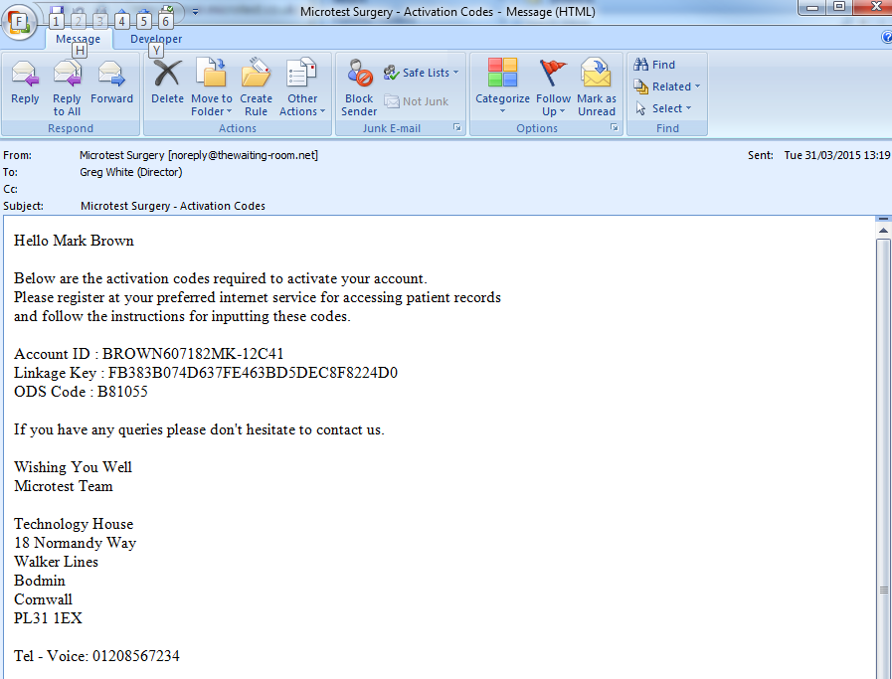
Alternatively, these may have been printed at the practice and given to you.

Creating an account at TWR
In order to access online services you now need to establish an account at www.thewaiting-room.net independently of these three data items . The three data items will be required just once.
First visit to The Waiting Room
When you first visit www.TheWaitingRoom.net you will need to click on the Register button

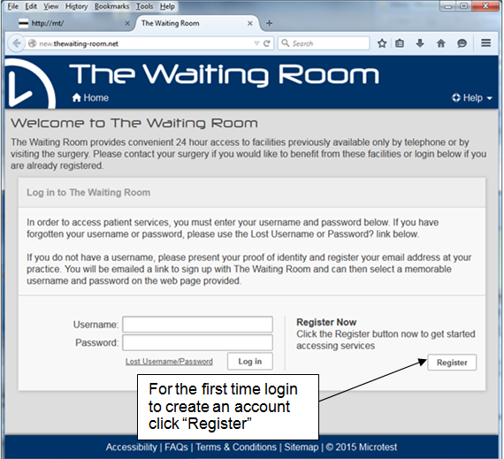
The Waiting Room registration screen requires a username, password, email address and an answer to the chosen security question before clicking on the Register button.

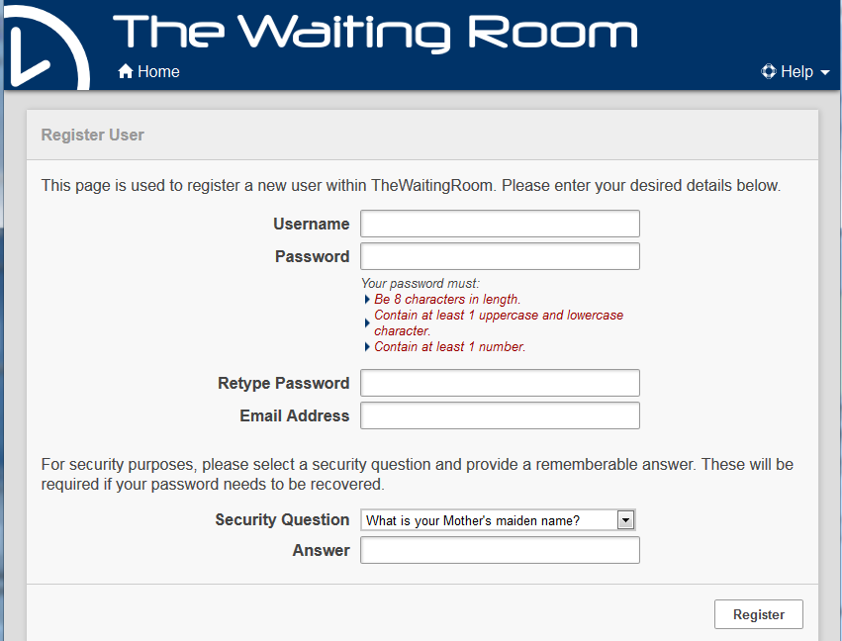
The information provided to you from your practice now needs entering to finally verify and create your online user account.
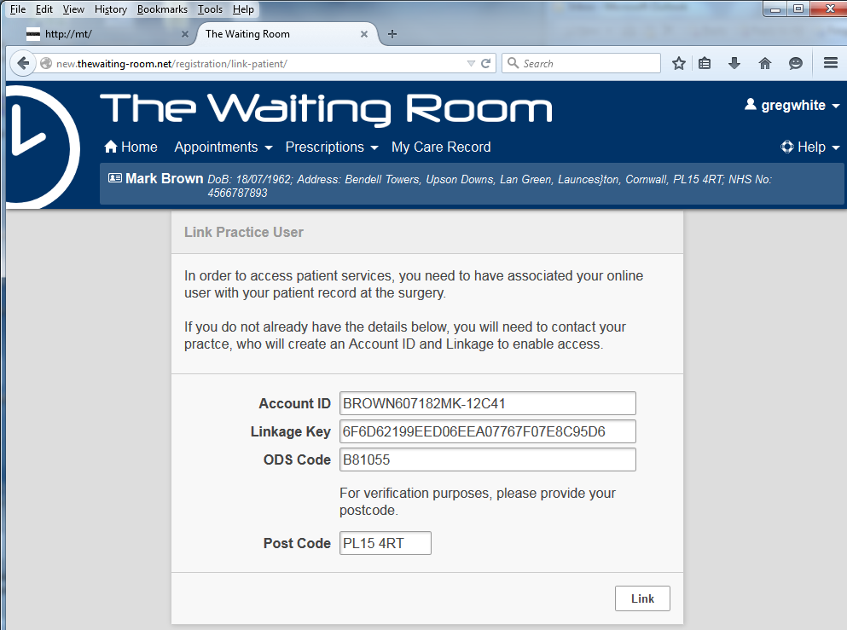
If sent you via email it is recommended that you copy (ctrl C) and paste (ctrl V) to copy the system generated Account ID, Linkage Key and ODS (practice) code into this form. Type in the postcode and press Link.

From then on - the online user will log on to www.thewaiting-room.net .

Subsequent visits to The Waiting Room
Future logons will simply require your username and password.

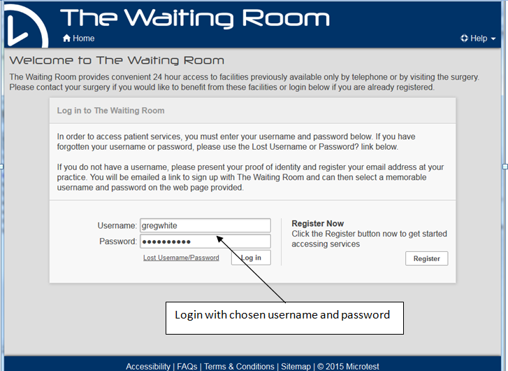

Lost or forgotten Username/Password
There is a standard “Lost Username / Password” procedure for the web site login which uses the security question to re-send the login details to registered email address.

If the online user’s account with the practice is disabled or the online user loses their Account Id, Linkage Key or ODS Code before establishing the link, they will need to get the practice to re-issue these details.

The Waiting Room - Home page showing the appointments and prescriptions
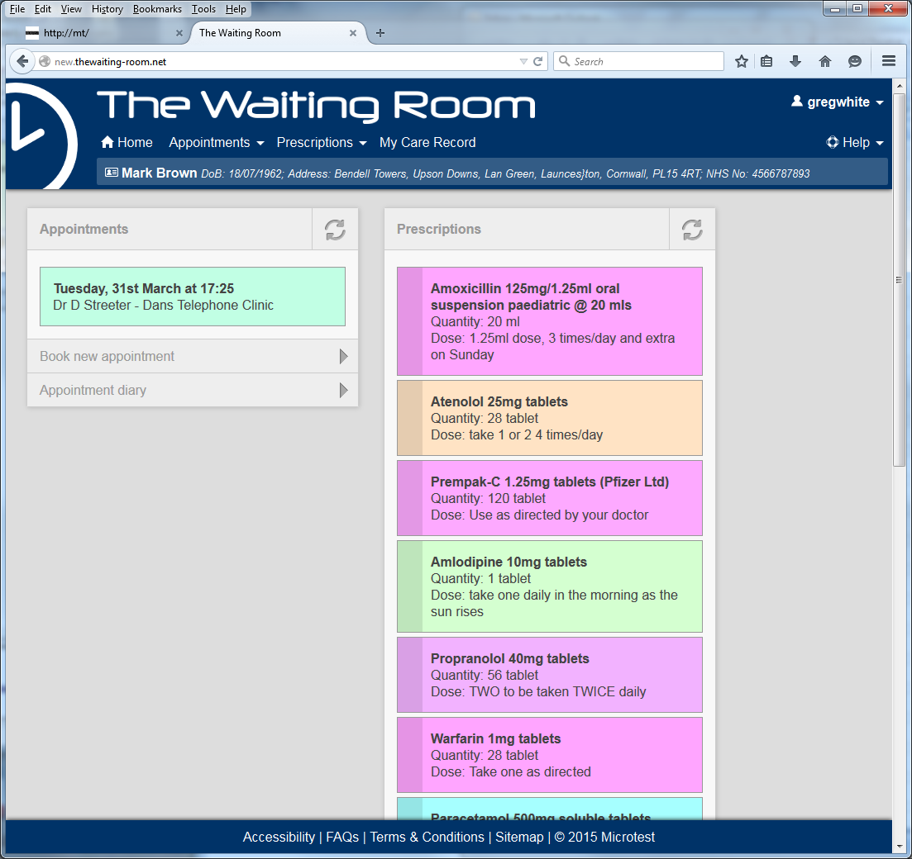

This page display a summary of all future booked appointments and a list of all the medication items that have been requested - at the side of the medication item the panel will show the status as:
- Requested - Waiting for the practice to process the request
- Confirmed - The prescription has been printed or sent electronically to the pharmacy
- Rejected - The GP has decided against writing a prescription for this item

Appointments

The Booking Screen
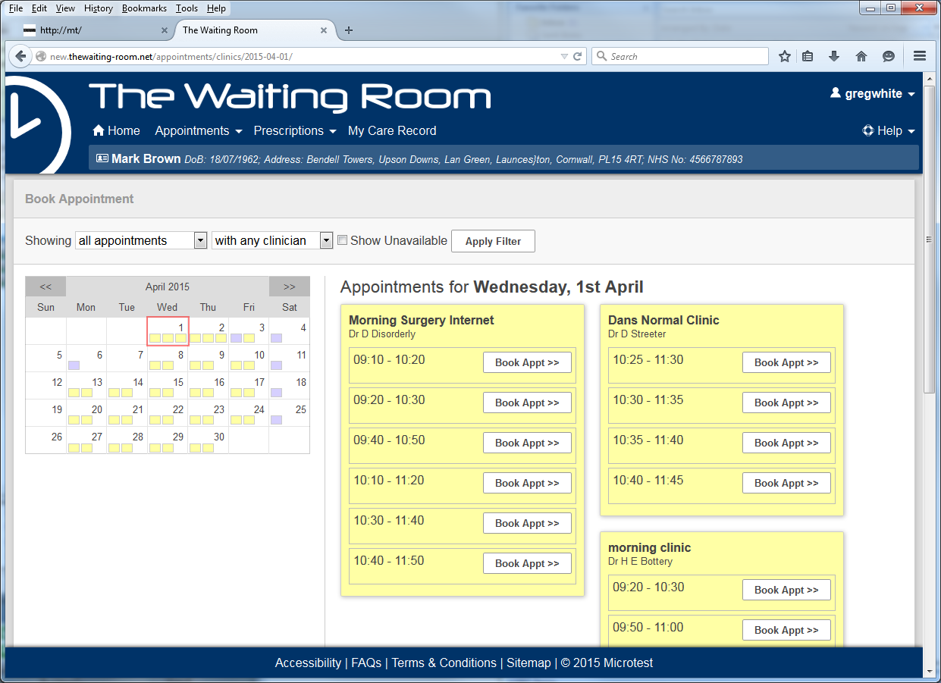
The appointment booking screen has a calendar and filters for:
- Appointment type e.g. telephone, or in the surgery
- Clinician any or a particular clinician

The appointments matching those criteria are shown. Clicking on Book Appt >> will display
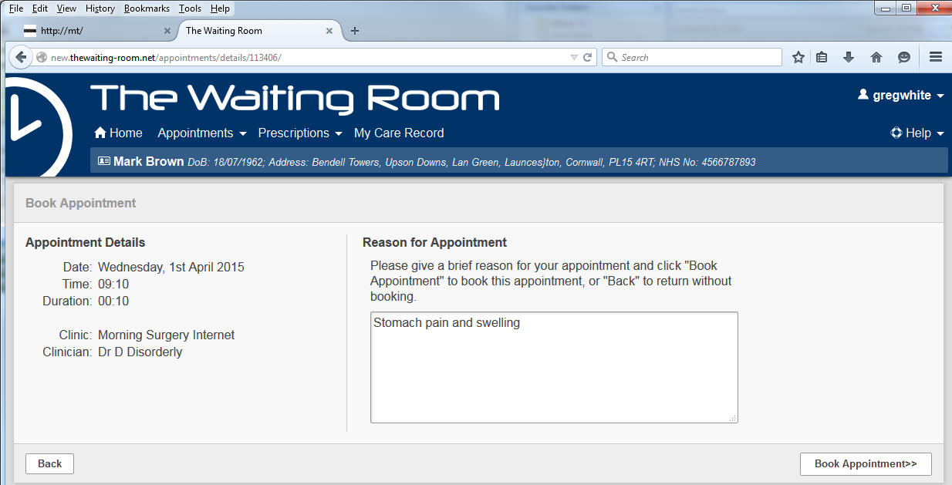
NOTE: All telephone appointment slots will require you to enter the telephone number you would like the practice to contact you on.

Successful booking
Although the system is “real time”, it is possible that another online user may book just beforehand and then there will be a message that the booking was unsuccessful.

Cancellation
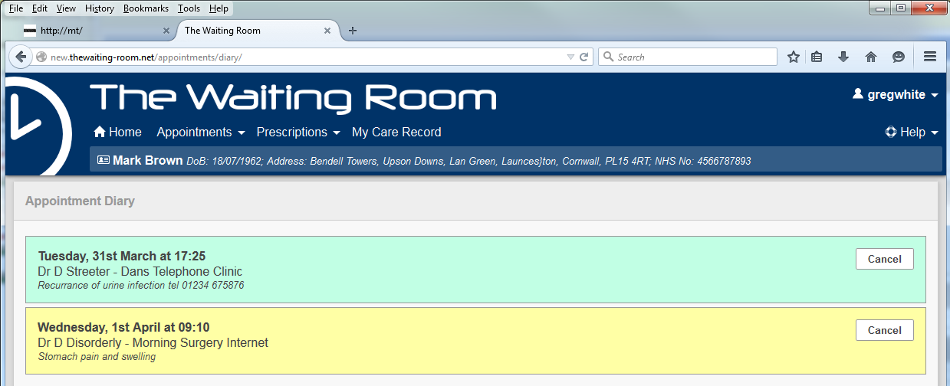
To cancel a booked appointment you simply need to navigate to the Appointment section of your The Waiting Room account and click on the cancel button.

Appointment Cancel screen
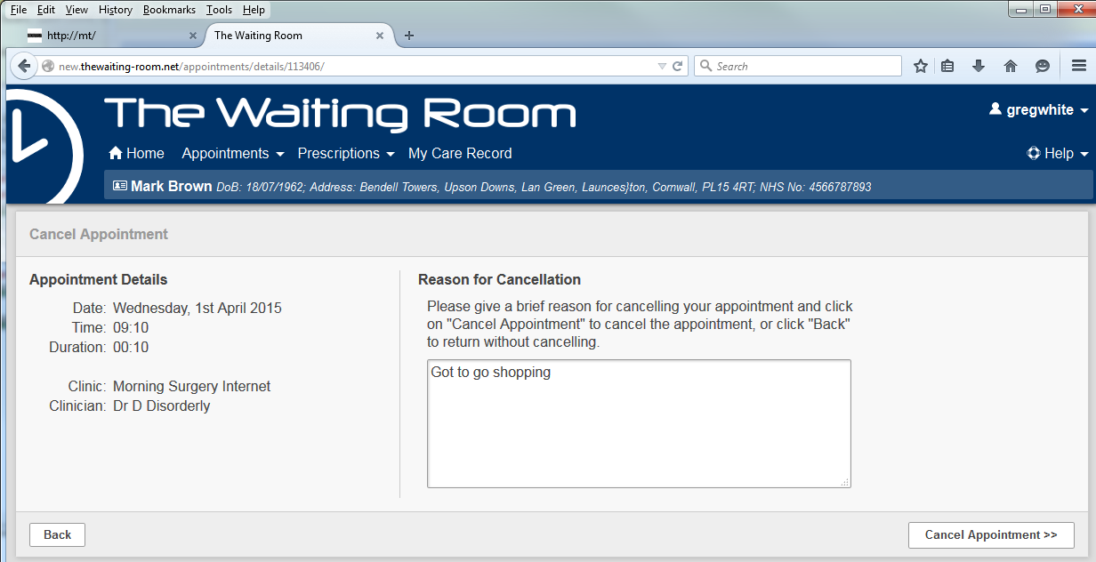
You may wish to enter in a reason for the cancellation before clicking “Cancel Appointment”.

Appointment Diary

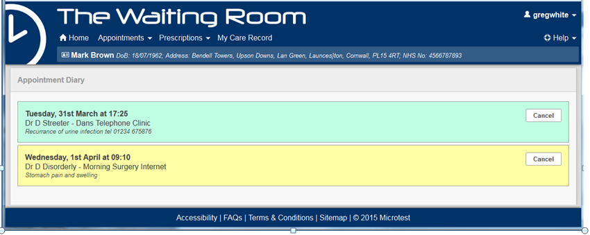
Within the appointments module, all your future booked appointments are displayed.

Prescriptions

Information on display
The prescriptions home page shows list of all the medication items that have been requested - at the side of the medication item the panel will show the status as:
- Requested - Waiting for the practice to process the request
- Confirmed - The prescription has been printed or sent electronically to the pharmacy
- Rejected - The GP has decided against writing a prescription for this item

My Prescriptions
This display shows each item with details that include:
- The full name of the drug
- The prescribed quantity and unit
- The dose instructions
- The last date the item was prescribed
- The interval to the next review
- The number of repeats remaining

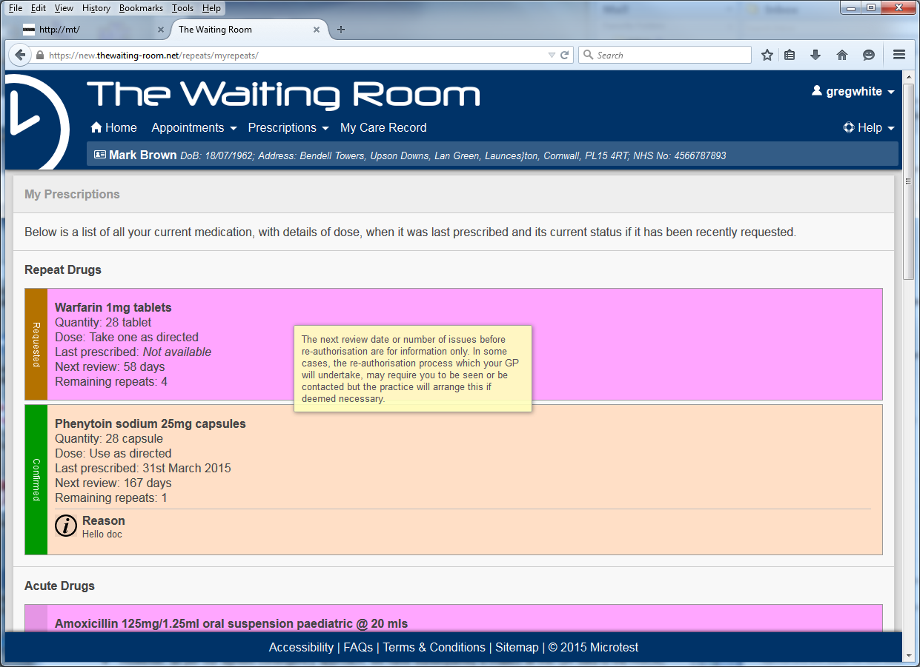

The medication review may only involve the clinical team reviewing the medication and there is no need to contact the practice if the review is imminent or the remaining number of repeats is low. If the practice requires you to attend a review appointment - they will get in touch.

Ordering a prescription
The display shows drugs that the practice has allowed to be ordered. Normally this will include repeat items that are taken regularly but may include other drugs that are normally only issued on a one off basis.

Drug order screen
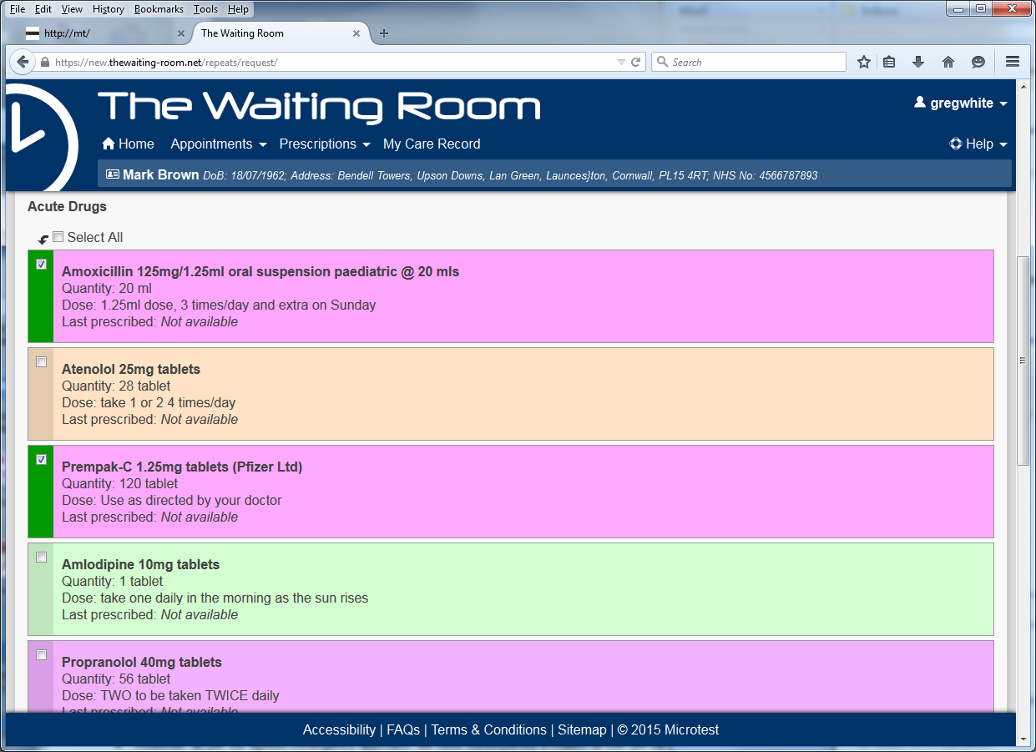
Simply click the side bar by each item or click the Select All box.
When the selection is complete scroll to the bottom of the screen and pres Next >>
Text to accompany a order
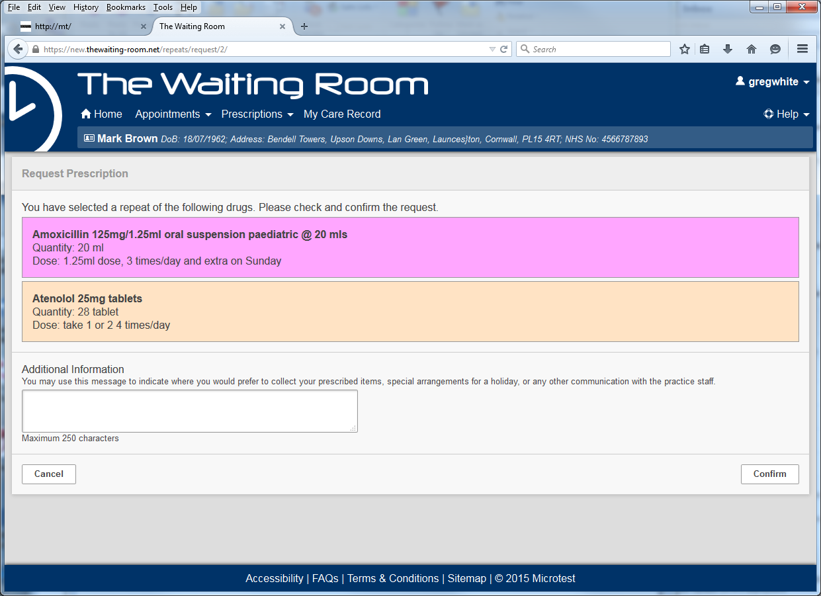
The select items are displayed and there is an opportunity to add a comment about the order if there are unusual circumstances surround the order. Click Confirm to continue or Cancel.

Acknowledgement - showing the order
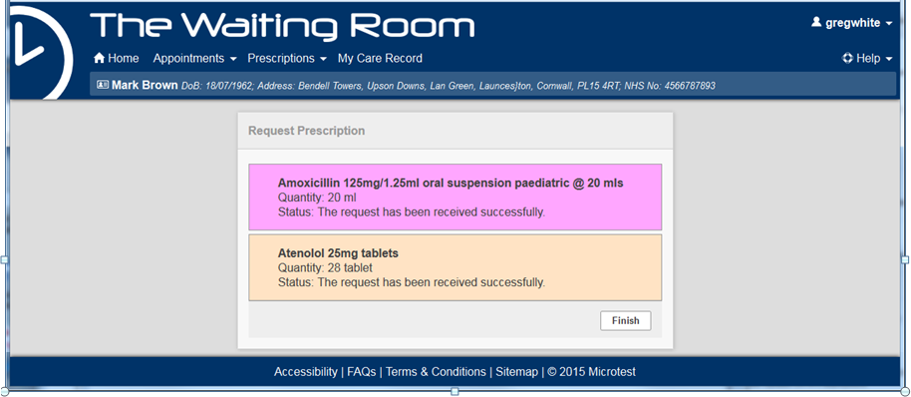

Prescription Raised
The status will change to Confirmed once processed by the practice.

Early Re-order warning
If two requests for the same item follow too closely - there will be a warning to the online user that the order is too early. The warning does not stop the order but may remind a patient that the item does not yet need re-ordering.

My Care Record
The option My Care record is in fact the Core Summary Care Record (Core SCR) which was devised for clinicians working in emergency care to be able to get a very limited view of your medication and allergies. As the beginning of being able to see all clinical records online, the Core SCR is a fairly uncontroversial starting point.

Heading
The Core SCR includes a disclaimer meant for the emergency care clinician that it may not include all the pertinent information. The SCR delivers a copy of what is available from the NHS system and it may not include some recent changes. This implementation of the SCR is completely up to date as at the time the online user requests it.

SCR consent
You may have asked the practice not to upload their records to the SCR system hosted by the NHS. Your access to this Core SCR is not bound by this consent status as typically you are seeing your own record and not making it available to the wider group of NHS clinicians.

Allergies and Adverse reactions
This is a list, held by the practice, of all the drugs to which you have had a recorded allergic reaction or an adverse drug reaction. An allergy is technically a specific type of reaction whereas an adverse drug reaction covers more general clinical manifestations. This gives the emergency care clinician a list of items to avoid prescribing or at least be warned of the consequences. The list also includes allergies to other things such as bee stings, latex, peanuts, wheat etc. The reason for including these allergies is they may be the cause of the patient receiving emergency treatment.

My Care Record - Heading, Allergies and Adverse drug reactions
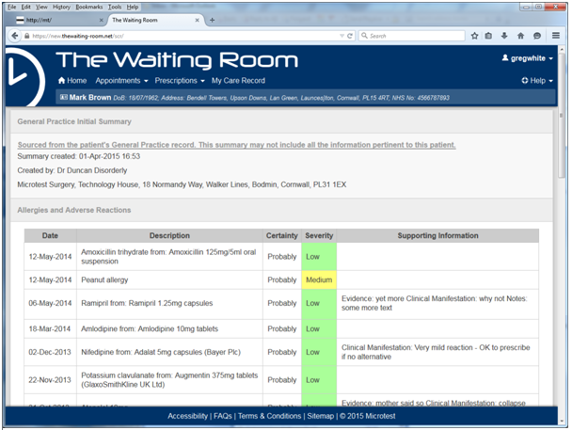

This access to your Core SCR is read-only. If you disagree with an entry, or wish to discuss it, you would need to make an appointment to see your GP.

Acute Medication
This is useful information for the emergency clinician to see if some new medication has had an affect on the condition to presenting with to them.
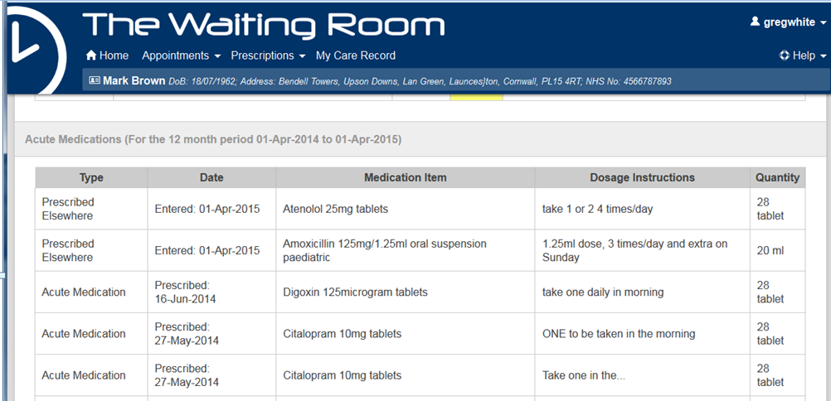

Current Repeat medication and Discontinued Repeat Medication
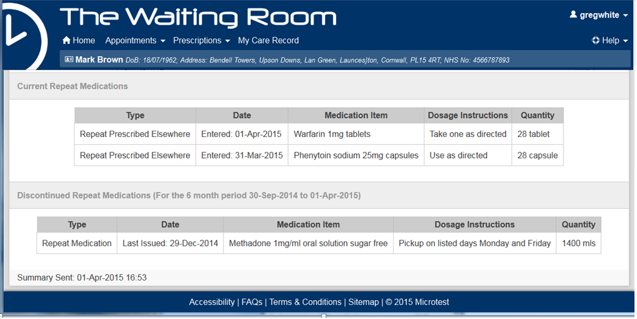

This is useful information for the emergency clinician to understand what regular medication you may be taking, the dose, strength and quantity and it gives a clue about the possible underlying medical problem. The information that the repeat item has been withdrawn is also useful.

Proxy Access
If you have been appropriately set up at the practice, and with patient permission, to access the clinical record of another patient at the practice you can access their record either by selecting them from the presented list when you first log in (see below) or by clicking on the icon and selecting from the list provided:-
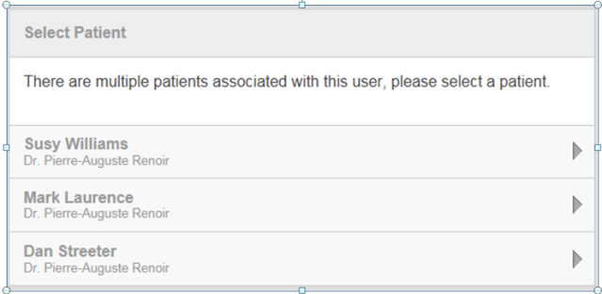

Depending on the practice setting and the level of access granted to you by the patient you may have all or some of the services available to you for the patient you are acting as a proxy for e.g. husband or wife, child, elderly parent etc.

Appendix A - Summary Care Record - Core Data Items
The data items included in the initial GP summary are medications, allergies, and adverse reactions.

Allergies and Adverse Reactions
These include the complete record of patient allergies and adverse reactions, including allergies to drugs, foods and substances, and drug interactions but excluding contra-indication codes used for administrative purposes.

Current Repeat Medications
- All repeat medications which have not been discontinued
- Medication authorised but not yet issued
- Medications prescribed elsewhere (e.g. hospitals or special clinics
- OTC (Over The Counter) drugs taken by the patient
- Repeat dispenses and post-dated prescriptions which have not been discontinued

Acute Medication
- Acute medication prescribed within 12 months
- Medications prescribed elsewhere e.g. hospitals or special clinics
- OTC (Over The Counter) drugs taken by the patient

Discontinued Repeat Medications
- All repeat medications and repeat dispenses which have been discontinued within 6 months
- Medications prescribed elsewhere e.g. hospitals or special clinics
- OTC (Over The Counter) drugs taken by the patient

